Objective 1: In-Depth Understanding of ‘Digital Forensics’ Process including the Main Stages – Identification, Preservation, Acquisition, Examination, and Reporting
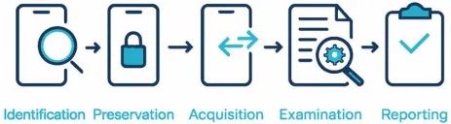
Notes on Readings
Practical Cyber Intelligence Ch.1-4
Ch. 1 – Intelligence Analysis
- Intelligence analysis: the process of using data to comprehend a situation or problem and support decision-making; collect and analyze data from various sources (human, signals, open-source, etc.)
- It’s not possible to always be precise in forensics given the data available
- Intelligence life cycle includes
  - Planning and direction: establish a strategy for gathering data
  - Collection: raw data from different sources
  - Processing: data is transformed to be easily understood by humans or interpreted by relevant computer systems, crucial for preparing analysis
  - Analysis: turning a complex problem/concept into smaller parts for better understand and draw conclusions, transform data into actionable information (critical thinking, logical reasoning, etc.)
    - Structured Analytic Techniques framework
      - Define the problem/issue
      - Collect and organize info
      - Apply SATs (identify patterns, trends and relationships) (statistical, network, geospatial, decision trees, Bayesian, etc.)
      - Develop conclusions/insights
      - Document and communicate findings
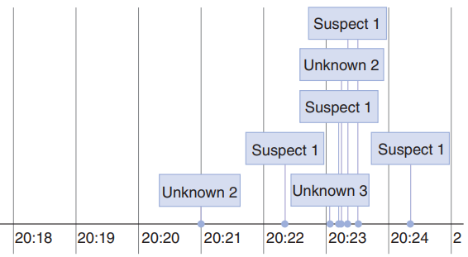
    - Timeline analysis: plot events by date and time, helps determine the difference between digital evidence and a base timeline (all data should be in the same time zone)
1 - Timeline Analysis Example
      - Develop a timeline
      - Identifies patterns and trends
      - Develop conclusions and insights
      - Select most likely explanation
    - Competing hypotheses: identify and evaluate all plausible explanations given the situation and choose the one that most likely occurred
      - Identifies all explanations
      - Develop a hypothesis for each
      - Evaluate evidence for each
    - Link (relational) analysis: identify connections between entities using network theory (info overload)
    - Attribution: identify the actor behind an event (part of intelligence analysis)
  - Dissemination: distribute the report, also crucial
  - Evaluation and feedback
  - Goal: deliver timely and accurate information to decision-makers
- Cyber kill chain: based on the military concept, if one chain breaks the whole attack falls apart
  - Reconnaissance: gather information
  - Weaponization: create a tool/payload
  - Delivery: deliver payload to target
  - Exploitation: exploit target’s vulnerabilities
  - Installation: install additional tools/malware
  - C2: establish foothold on target’s system
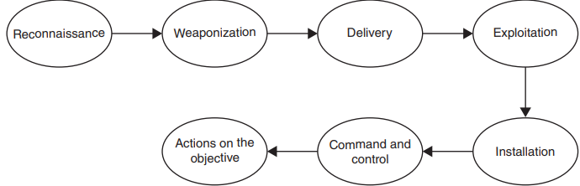
  - Actions on objectives: carry out main objectives (steal data, disrupt operations, damage system, etc.)
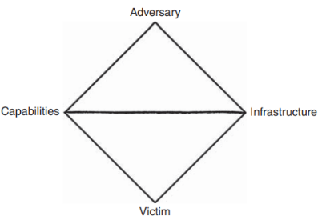
- Diamond model: understand and analyze motivations, capabilities and actions of a threat actor (developed by NSA)
2 - Cyber Kill Chain Visual
  - Adversary: performs the attack
  - Capabilities: level of expertise
  - Infrastructure: network and system used to deploy attack
  - Victim profile and defenses: what was targeted
3 - Diamond Model Visual

Ch. 2 – Digital Forensics
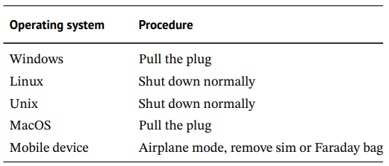
- Digital forensics: using scientific methods to preserve, analyze, and present digital evidence (goal: answer the 5 Ws and the how); identifies motive, means, and opportunity
  - Includes all devices and components (computers, mobile devices, storage, cloud, IoTs, network)
4 - Live Device Handling
- Collection takes many forms (docs, emails, videos, audio, social media, etc.) and follow protocols to avoid compromising integrity
- How to preserve evidence: isolate the device, write-blocking, imaging, hashing, chain of custody, backup and redundancy
- Acquisition: process of extracting data from devices during an investigation
- Processing: converting raw data into a format for analysis
- Analysis goal is to determine what happened (timeline, activity, relationship, functional)
  - Signs of evidence destruction
    - Change in hardware
    - Empty cache
    - Lack of user data/apps
    - Inconsistent database
    - Altered creation date of files
    - Selective deleted messages/history
- Reader must fully understand the report
  - Goal: present highly complex technical info in a way for non-technical people to understand
- 4 C’s of writing: clarity, coherence, conciseness, correct
Ch. 3 – Disk Forensics
- Disk forensics is essential
- Smallest unit of a disk is a “sector” (512 bytes), reading a file with one byte = reading the whole sector
- Always create an image of the disk before working, DO NOT WORK WITH ORIGINAL
- Always use a writeblocker when attaching a disk, this ensures no unforeseen changes are made
- Acquisition: create disk image and generate hash
- Prep: verify integrity (compare hash of image and expected) and write protection (remove writing access)
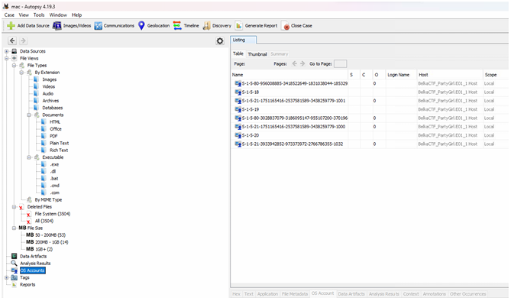
- Autopsy: analyzes digital media to identify evidence related to a case
5 - Autopsy Software via SleuthKit
- Self-Monitoring, Analysis, and Reporting Technology (SMART): a system integrated in hard drives and solid-state drives, monitors the health and performance
- File carving: extracting files from a disk image when the original file is unavailable/damaged, looks for patterns to indicate the presence of a file
- Disk forensics is becoming less common due to the increased use of encryption and closed systems, but still critical for understanding all storage devices
Ch. 4 – Memory Forensics
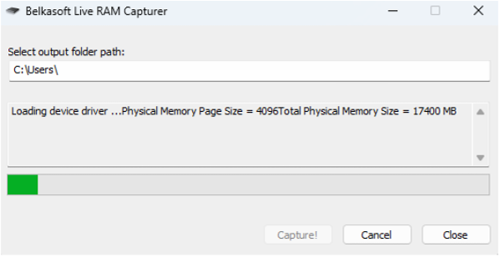
- Memory forensics: focuses on examining a computer’s RAM (volatile/short-term memory) to recover and analyze digital evidence, involves capturing contents that may not be on storage devices (must be done during live forensics)
- Requires lots of knowledge on how a computer memory works
- Acquisition: dumping memory using simple built-in software (choose the right tool for the right system)
6 - RAM Capture via Windows
- Analysis: requires specialized tools for interpretation
Digital Forensics Ch. 1-4
Ch. 1 - Introduction
- Forensic science: uses scientific methods to establish answers
- Forensic analyst: reconstructs and analyzes all data at all levels to determine what is relevant
Ch. 2 – Digital Forensics Process
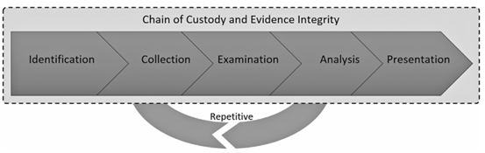
- Cybercrime will always be one step ahead of defenses, attackers know all defenses, but defenses doesn’t know all possible attacks
- Identification w/ the 5WH model: who, what, where, when, why, how
- Digital crime scene = sub-environment of a physical crime scene
7 - Digital Forensics Process
- Evidence integrity = preserve it as it is found
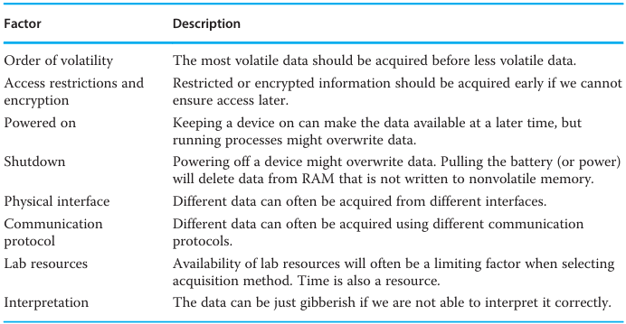
- Chain of custody
  - Copy evidence as read-only
  - Create DS for both copies to verify
  - Analyze evidence copy, not original (original remains untouched)
- Examination = prep for analysis
- Anti-forensics makes forensics more difficult by eliminating/reducing evidence
8 - Factors that Affect Access to Information
Ch. 3 – Cybercrime Law
- Cybercrime law: the legal regulation of digital crime and evidence
- Digital forensics operates within legal frameworks
- Cybercrime often crosses borders, so cooperation is essential
- European Convention of Human Rights include
  - Right to fair trial
  - Legality principle
  - Transborder search and surveillance
  - Positive obligations of states
- Cybercrime convention: agreement b/w states about certain cybercrimes; primary international treaty (defines offenses and procedural powers)
- Liability includes intent, negligence, causation, and unlawfulness
- Principal of legality = conduct is only criminal under “criminal offense” definition
  - Criminal offense: defined by conditions in a formal legislation of the national legal system
- Common violations
  - Confidentiality: illegal access, interception
  - Integrity: data/system interference
  - Availability: DDoS, sabotage
  - Misuse of devices: malware, hacking tools
  - Computer-related offenses: fraud, forgery
  - Content: child exploitation, hate speech
  - Copyright
- Investigation methods
  - Public data
    - Open-source intelligence techniques (OSINTs)
    - Open websites
    - Public logs
  - Search + seizure must follow strict procedures (special issues include smartphones, cloud data and third-party data)
  - Production orders compel entities to provide stored data
  - Real-time collection includes traffic data (on the network), interception, and monitoring
- International cooperation is needed in order to counteract transborder digital crime and collect evidence for most investigations
  - Mutual legal assistance treaties (MLATs)
  - Joint investigation teams are set up with a mandate of a specific criminal investigation (usually encouraged)
- A national procedural system is in compliance with fundamental conditions as long as the system as a whole is satisfactory
Ch. 4 – Digital Forensic Readiness
- Digital forensic readiness: the ability to perform with minimal cost while maximizing the use of evidence
  - “What does it mean to be ready?” It means being prepared
- Law enforcement is reactive and case-driven, while enterprise readiness is proactive and policy driven
  - Focuses on incident response and compliance (adhering to legal and ethical standards)
  - Minimal cost and disruption to business operations
- Readiness matters because preparedness reduces cost of time dedicated to the investigation and ensures the evidence gathered is preserved correctly, maximizing its usefulness
- Standards
  - ISO/IEC 27037: digital evidence and its principles of relevance, reliability, and sufficiency
  - ISO/IEC 17025: management and technical requirements for a forensic lab
  - NIST SP 800-86: the phases of the digital forensic process – collection, examination, analysis, and reporting
- Guidelines
  - IOCE: used for implementing digital forensic examination procedures
  - Scientific Working Group on Digital Evidence (SWGDE): lists the types of errors found in digital forensic tools – incompleteness, inaccuracy, and misinterpretation
  - European Network of Forensic Science Institutes (ENFSI): guidance for forensic labs and the framework for procedures, quality principles, training processes, and approaches
- Research frameworks
  - Rowlingson’s 10-step process: a framework for digital forensic readiness in corporate and enterprise environments
  - Grobler et al.’s Forensic Readiness Framework: introduce the notion of comprehensive digital evidence; carries evidentiary weight which has legal risks and requirements when being collected
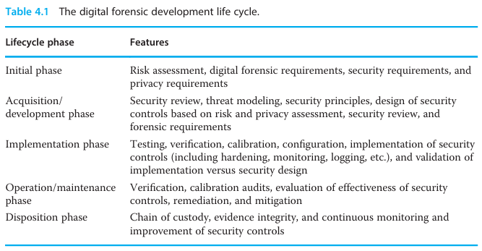
  - Endicott-Popovsky et al.’s Forensic Readiness Framework: consists of several layers to aid enterprises in implementing forensic readiness
9 - Digital Forensic Development Life Cycle
- Becoming forensic-ready includes legal compliance, clear policies to follow, training people to be aware of the risks and their roles, having the right technology and using it correctly
  - These approaches require continuous improvement as things change over time
  - Outsourcing may be needed depending on the investigation, but still requires the same level of oversight
Learn Computer Forensics Ch.1-4
Ch. 1 – Types of Compter-Based Investigations
- Everything is tracked through technology
- Almost all activities generate digital evidence
- Goal: Identify, collect, and examine/analyze digital data while preserving integrity
- Prove both innocence and guilty activities
- Best students: examine facts and circumstances, and use it to draw an accurate conclusion
- Criminal investigations
  - First responders: id potential victims, witnesses, potential suspects, maintain control of the scene (safe and secure); done until the investigator arrives
  - Investigators: coordinates with first responders, takes charge and directs all activity, ensures proper documentation is completed
  - Crime scene technician: special training in evidence collection (physical), digital evidence requires the same level of expertise
- Stalking has increased online due to its anonymity
- Cyberstalking/cyberbullying is now regulated and considered an actual crime, but definition varies based on jurisdiction
  - Must listen to the whole story
  - Have an open mind and do not let preconceptions miss evidence/indicators
  - Note all information
  - Threats of violence may escalate
- Conspiracy: when two or more people agree to commit an illegal act
  - Actions must be taken to further the conspiracy to be enough to investigate
- Corporate investigations
  - Search warrants are needed by the government, but as an employee using company equipment, there is a limited expectation of privacy
  - Process stays the same: acquire, analyze, present findings
  - Policy: a statement from the organization addressing a specific issue
  - Procedure: specific instructions regarding how to accomplish the goals of a policy
- Employee misconduct includes policy violations, harassment, and misuse of company systems
- Corporate espionage: one organization spying on another to achieve commercial/financial gain
- Security incidents include malware, unauthorized access, and insider threats
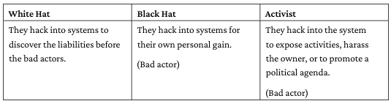
- Threat actor: a malicious user gaining access to information systems that don’t belong to them, can be insider or outsider threats
10 - 3 Types of Threat Actors
- Social engineering: usually done through a phishing attack to gain access to confidential information; more common in corporate environments
- Related case studies
  - Dennis Rader (the Bind Torture Killer): metadata within documents was used to help identity the killer
  - Silk Road: first online black market hosted on the dark web; digital evidence tied Ross Ulbricht to activities
  - San Bernardino terror attack: an attack was done using semiautomatic rifles and explosives; faced challenges when trying to gain device access
  - Theft of intellectual property: an insider threat misusing corporate systems for personal/political gain
Ch. 2 – The Forensics Analysis Process
- It’s important to consider proper planning before conducting an investigation to ensure efficiency
- The forensic workstation must have a high-performance machine with write blockers, large storage, forensic software suites, and a secure environment
- The response kit includes tools for filed collection like cables and adapters, write blockers, storage media, documentation forms, and bootable forensic media
- Examiners must stay up-to-date with current OS changes, file systems, and tools as part of their training
- Government investigators require search warrants, private investigators don’t
  - Both must follow policy and law
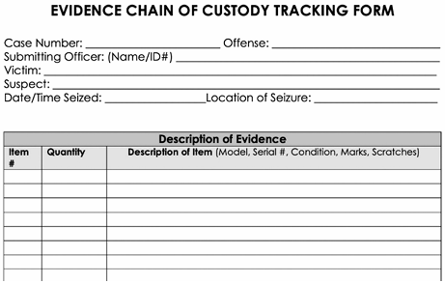
- Chain of custody requires that every handoff is documented to track where the evidence goes and maintain control of who has access to it
11 - Sample Chain-of-Custody Form
- Part of the analysis process is normalizing timestamps (local vs. UTC), identify known files with hash analysis (whitelisting/blacklisting), detect mismatches in file signatures (extension vs. filetype), and antivirus (in case malware evades detection)
- A forensic report must include case details, tools used, steps taken, findings, limitations, and clear, non-technical explanations
Ch. 3 – Acquisition of Evidence
- When exploring evidence, all potential sources must be identified (computers, phones, removeable media, cloud accounts)
- The examination environment must be controlled, isolated, and secure to prevent contamination/alteration
- All tools used in an investigation must be tested and validated before use to ensure reliability and admissibility in court
- Sterile media is a clean, verified storage to ensure no contamination of previous evidence; hash is done before and after to confirm integrity
- Write blocking prevents modification of original evidence; hardware blockers are physical devices while software blockers protect at the OS-level (less reliable)
- Forensic image: bit-for-bit copy of a device
  - FTK imager previews, acquires and verifies images
  - PALADIN: bootable Linux-based forensic environment
Ch. 4 – Computer Systems
- The boot process helps examiners control system startup, avoid altering evidence, and use forensic boot media safely
  - Booting a suspect machine can change timestamps, modify logs, alter system files, and/or trigger malware/encryption
  - Understanding how to boot is essential for safe acquisition
- Power-On-Self-Test: the CPU accesses the Read-Only Memory (ROM) and Basic Input/Output System (BIOS) and test motherboard functions
  - Checks CPU, RAM, keyboard, and storage controllers
  - Errors may indicate hardware tampering/failure
    - BIOS was later replaced by the Unified Extensible Firmware Interface (UEFI), same services
  - Loading the OS with the test can reveal failed logins, driver tampering, and malware persistence
- Boot media allows examiners to boot a system without touching the internal OS; must be configured correctly to avoid writing
  - Key requirements: write-blocking, multiple file systems, hashing and verification
  - This can only be done with trusted tools to create a read-only boot environment
  - A normal boot-up can destroy evidence or trigger anti-forensic tools
  - This prevents OS from altering timestamps, avoids malware activation, ensures forensic soundness, and allows imaging even when OS is corrupted/encrypted
- Creating a bootable forensic device
  - Download a trusted ISO for the OS
  - Write the ISO to a USB using a tool like Rufus
  - Configure BIOS/UEFI by disabling the secure boot (if needed), setting up the USB as the first boot device, and ensuring internal drives remain read-only
  - Test the device: validate that the drives aren’t mounted to read-and-write and confirm the forensic tools are functioning correctly
  - All changes to the system must be documented
- HDDs are magnetic-based drives that store data on spinning platters and holds deleted data longer
- SSDs are flash-based drives that uses wear-leveling, trim to wipe the unallocated space of the device, and garbage collection
  - Special acquisition methods must be used to recover deleted data

